A

Project Report

On

“APPOINTMENT+.COM”

Submitted to

CHHATTISGARH SWAMI VIVEKANAND TECHNICAL UNIVERSITY,

BHILAI

In partial fulfillment of requirement for the award of degree

Of

Bachelor of Engineering

In

Information Technology

By
Anima Sharma
&
Jasmeet Kaur

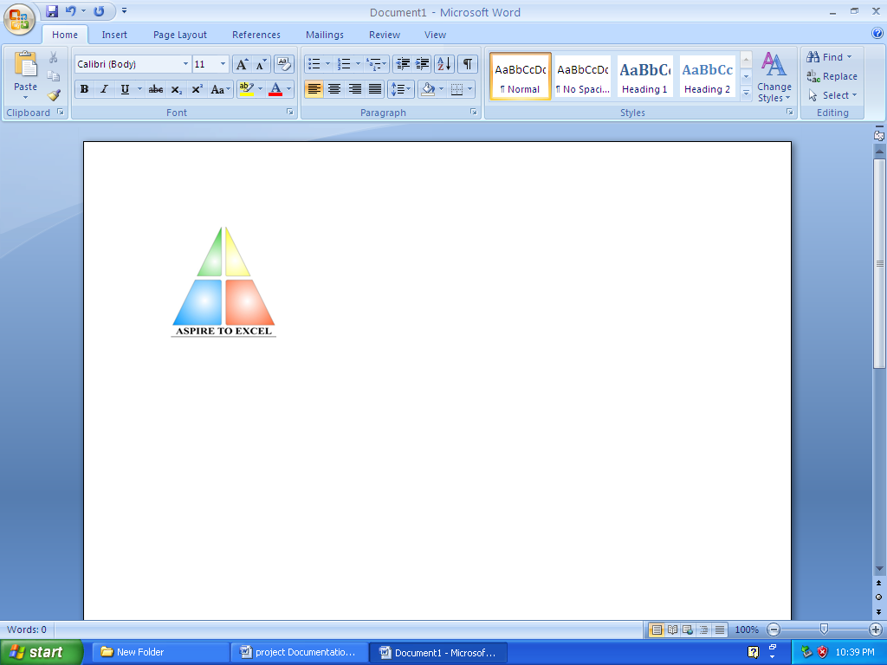

Department of Information Technology,Bhilai Institute of Technology, Bhilai House, Durg, Chattisgarh -491001.

Session: 2006-2010

CERTIFICATE

This is to certify that the report of the project submitted is an outcome of the project work entitled “APPOINTMENT+.COM” carried out by
SNO | NAME OF STUDENT | ROLL NO | ENROLLMENT NO
1. | ANIMA SHARMA | 3013306007 | AA9810
2. | JASMEET KAUR | 3013306016 | AA9839

Carried out under my guidance and supervision for the award of Degree in Bachelor Of Engineering in Information Technology of Chhattisgarh Swami Vivekanand University , Bhilai (C.G) , India .

To the best of my knowledge the report
- Embodies the work of the candidate him/herself ,
- has duly been completed,
- Fulfils the requirement of the Ordinance relating to the B.E. degree of the University and
- Is up to the desired standard for the purpose of which is submitted.

____________________
(Signature of the Guide) Name of Guide : Mr. Rajkumar Singh Designation : Lecturer Department : I.T. Institute : B.I.T., DURG
The project work as mentioned above is hereby being recommended and forwarded for examination and evaluation.

(Signature of HOD with seal ) _______________________________

CERTIFICATE BY THE EXAMINERS

This is to certify that the project work entitled

“APPOINTMENT+.COM”

Submitted by
SNO | NAME OF STUDENT | ROLL NO | ENROLLMENT NO
1. | ANIMA SHARMA | 3013306007 | AA9810
2. | JASMEET KAUR | 3013306016 | AA9839

has been examined by the undersigned as a part of the examination for the award of Bachelors of Engineering degree in Information Technology of Chhattisgarh Swami Vivekanand University , Bhilai (C.G) .

___________________ ___________________
Internal Examiner External Examiner
Date: Date:

ACKNOWLEDGEMENT

Working on this project has been a great learning experience for us. There were moments of anxiety, when we could not solve a problem for several days and there were moments when we could solve a problem after struggling for several days. But we have enjoyed every bit of the process and are thankful to all people associated with us during this period.

We convey our sincere thanks to our project guide Mr.Rajkumar Singh, for providing us all sorts of facility. His support and guidance helped us to carry out the project. I owe a great debt of his gratitude for his constant advice, support, co-operation and encouragement throughout the project.

We would like to express our deep gratitude to respected H.O.D Information Technology Department Mrs. Arpana Rawal madam for her helpful solutions and comments enriched by experience, which improved our ideas for betterment of project.

It will be our pleasure to acknowledge, utmost co-operation and valuable suggestion from time to time given by Mr. Amrendra Singh (Project In-Charge) and also we would like to thank all those persons who have directly or indirectly helped us by providing books and computer peripherals, and other necessary amenities which helped in the. development of this project which would otherwise have not been possible.

_______ ________
(Anima Sharma) (Jasmeet Kaur)

Information Technology, 8th Semester
Bhilai Institute of Technology, Bhilai House, Durg, Chattlsgarh-491001

TABLE OF CONTENTS

- Introduction
- Literature Review
- Problem Identification
  - Current System
  - Solution Strategy
  - Feasibility Study
  - Programming Team Structure
- Methodology
  - Hardware Requirements
  - Software Requirements
  - Technology Used
  - Life Cycle Model
  - Work Flow Diagram
  - Database Design
  - Testing
- Coding
- Snapshots
- Conclusion & scope of further work
- Bibliography

INTRODUCTION

INTRODUCTION

Our project aims at helping clients to get an organization’s details and maintain their appointments with the respective organization and to facilitate organizations to manage their own clients. It allows the users to create or modify appointments online. It is a single website which keeps records of various organizations appointment schedules and manage them in appropriate manner. It provides facilities for taking new appointments, rescheduling existing appointments or deleting unnecessary appointments.

The databases of information are maintained in an appropriate manner so as to enable the retrieval and entering of the information.

The site also fulfills the following objectives:
- To provide the information about various organizations.
- To provide the organizations the fascility of updating their records.
- To provide information about specialists whose appointment is to be taken.
- To provide the organization the information about its clients by creating accounts.

LITERATURE

REVIEW

LITERATURE REVIEW

While taking appointments the users are bound to visit the organisation personally or make it through telephone. This is time wasting and inconvenient for persons who are not able to visit the organisation each time they need to fix an appointment with an specialist.
Also while taking appointment we must be sure about the validity and efficiency of organisation and any other preferences(if exists).Collecting all this information is a tedious task and sometimes the sources of information are also not reliable.

We are making this project for all the people who want to know about the particular organization and the specialist. For people who are not able to visit the place each time they need an appointment. We are providing the information about various specialists and also provides relevant details about organizations.

Web Design Process

Designing a web site is a process consisting of six phases:
.:. Project Definition
.:. Visual Design
.:. Site Development
.:. Testing
.:. Launch
.:. Maintenance

- Project Definition
The most critical step in the web design process is creating an accurate project definition. A project definition includes a project brief and a project plan. The client survey is used to gather the information needed to develop the project brief and plan.

How do you create the project definition?

Step 1: Conduct a Client Survey Interview - The purpose of this interview is to determine the purpose of the project, the target audience, branding/perception goals, content source, technical specs and communication strategy. Use this client survey to guide your interview.

Step 2: Write the Project Brief/Creative Brief - Based on the information gathered in the client survey, write the project brief to define in black and white the project goals, audience profile, audience perception, primary message and competitive advantage. Here is a sample project brief.

Step 3: Write the Project Technical Specifications -Using the information gathered in the client survey along with the technical standards of your organization, document the Technical Specifications to clearly establish requirements like screen resolution, browser compatibility, download time, web standards and accessibility. Here is a sample technical specification.

Step 4: Develop the Project Plan Timeline - Establish the timeline for deliverables and tasks for each phase of the project. Assign due dates and resources.

Step 5: Document Maintenance Considerations -Develop a web site maintenance plan that documents how the site will be updated and reviewed regularly.

- Visual Design
"Structuring the site on paper before starting visual design is a critical step toward effective presentation of content toy our intended audience."

"Designers are not mind readers or magicians. Good design is dependent on good site structure and a solid project definition."

The designer(s) should also review any branding guidelines as well as the technical requirements for screen resolution, browser compatibility, download time, web standards and accessibility.
At this point, the designer(s) has a clear idea of the purpose of the site, the content that will comprise the site, the site architecture and the elements that need to be on each page.

Drawing on their knowledge of design principles (balance, rhythm, proportion, and dominance), design elements (point, line, shape, color, typography) and user centered design (usability); they can develop design options that meet the project goals.

A sample of the visual design tasks:
- 1st draft of visual designs for home page and one sub-page.
- Client provides feedback on designs.
- 2nd draft of visual designs for home page and one sub-page.
- Client selects design and provides feedback.
- 3rd draft of visual design for home page and all unique sub-pages.
- Client provides feedback on design.
- Final visual designs for home page and all unique sub-pages Client approval of final design.

- Site Development
Now it is time to actually build the site. There are two major steps during this stage:
---Technical/Functional Plan
---Build and Integrate the Site

- Technical/Functional Plan-
Start by reviewing the Project Brief, Site Structure and Visual Design and confirm that everything is in alignment and supports the overall project goals and needs. Next, set the technical/functional specifications for the site:

Target Technical Specs - what browsers, as, resolution and connection speeds will you target.

Browsers* - what browsers will you target?
Operating System* -MAC, Windows, Others?
Display Resolution* -what is the screen resolution the site will be designed for? What other screen resolutions will be supported gracefully?
Connection Speed* - what is expected connection speed for your primary users, what other connection speeds will you target?

Functional Specs - what functionality does your site require? Use of W3C web standards is recommended to insure that your site pursues the goals of web for everyone and web on everything.

Project Plan - review your original timeline and the technical and functional specs you've just established. Do you have the resources you need to complete the project on time and within budget? Refine and add details to the project plan you drafted during the Project Definition Stage. Your project plan should now include a detailed list of concrete tasks, assignments, target dates and dependencies between tasks.

- Build and Integrate the Site
To turn all this planning into reality! The steps include:

Build templates using web standards:

- CSS -separate presentation from content
- (X)HTML-use valid (X)HTML
- JavaScript-add scripting, make sure to maintain accessibility
- Optimize -optimize images, CSS and (x) html
- Run initial tests on templates

Create Pages:
- Pour content into templates.
- Establish method for content contributors to review, update and add content.

Backend Development:
Code dynamic features of the site that require database/ CGI and integration like:
- Search
- Personalization/login
- Secure transactions
- Web analytics

- Testing
Your original project plan should always allocate time for formal testing. Ideally, you should identify a person to serve as the Quality Assurance Lead. This individual's priority will be to create a realistic QA plan, manage the testing process, prioritize issues, insure that high priority issues are solved and conduct the final review and release of the project.

Quality Assurance Testing
- Content - accurate, understandable, spelling, grammar (review conducted by content contributors / content editors).
- Links - review site for broken links Functionality -does the site perform the functions defined in the original project definition, create task list and conduct methodical testing.
- Validity -validate (X)HTML, validate CSS.
- Browser/OS/Resolution - test site on the target browsers your defined earlier either manually or using browser cam.
- Connection Speed - use the Web Page Analyzer to get analysis and recommendations on the speed/size of your pages.
- Usability-conduct informal or formal usability testing with your target audience.
- Load Testing - contact your server administrator to discuss load testing techniques.
- Security-request automated Security Scan, review file authorizations, etc.

Prioritize Issues
Taking the time to conduct testing prior to production is an important element in launching a high quality site. However, if you wait until the site is perfect, you will never launch.

There is a balance between perfection and realistic quality that must be struck. As you monitor the list of issues that are uncovered during the testing phase, prioritizing them in at least three categories:

Priority 1 - critical, must be fixed before launch.
Priority 2 - would enhance the site, but we can go live without it, address as soon as time permits.
Priority 3 -future enhancement, nice idea/feature, will consider for future release.

- Launch
As the site gets ready to go production, it is important to document the style guide. A style guide consists of the following elements:
- Visual Design Standards- logos, colors, typography(to keep the site on brand).
- Naming Conventions- for files, directories, CSS, images, titles.
- Site Structure- document the site diagram and indicate how the structure is built to handle growth.
- Templates- provide the (X) HTML templates and CSS indicating layout, typography, size, color, navigation, menus.

If possible, consider a soft launch (a quiet beta launch that allows you to confirm everything is up and running before the official launch date).

- Maintenance
Implement the maintenance plan that was developed in the first stage of this process. Emphasize the importance of keeping a project:
- Complete
- Current
- Coherent
- Accessible
- Attractive
- Robust
- Secure
- Cost Effective
- Aligned with the spirit and goals of the project

PROBLEM IDENTIFICATION

PROBLEM IDENTIFICATION

3.1 CURRENT SYSTEM:

The information about various organizations and specialists is only available in the printed media and the information is provided via the mass media are basically the advertisements which are very less in number and also does not provide the actual information. So, the best one could do is to get the information from friends, relatives, newspapers and television sometimes these sources are not reliable since they are only advertisements or personal experience of other people.
Also the various phases that are to be faced before confirming any appointment are tedious and time wasting. The organizations were also not able to provide their updated information to the clients.
.
3.2 PROJECT SOLUTION STRATEGY:
On completion of the project our website will be able to be provide all the information related to organizations and specialists and the user will just need an internet connection through which he/she can easily log on to APPOINTMENT+.COM and get the desired information and fix an appointment.

Beneficiaries of the project:

- Clients seeking for appointments
- Organizations willing to provide appointments

3.3 FEASIBILITY STUDY
It is very important to do preliminary investigations regarding the development of the system to ensure its possible usefulness for the organizations.
Thus before developing a system, it is necessary to test the feasibility of the project.

There are five aspects to be covered for testing project feasibility:

Technical Feasibility: The development of a system is technically feasible as the various technological needs for the development & deployment are fulfilled. The system is to be developed using familiar software & hardware tools (PC, Hard Disk, Java 1.6, and Web browser).

Operational Feasibility: This feasibility depends much on the willingness of the users to accept the system replacing their manual or old systems. As the users propose this system, its operation is much feasible .The only thing is that the users of the proposed system should be trained for using the system. The willingness to learn the new system developed makes the system much more feasible.

Implementation Feasibility: The organization has all the facilities required for developing the system. All software's required for the developments of the system are provided by the organizations & has got the necessary infrastructure, which makes the project feasible in implementing.

Schedule Feasibility: University allocates the time of weeks for the project, which seems to be enough for the development of the system as per the requirements put forward by the organizations. So, we can say that the project is feasible in terms of schedule.

Economic Feasibility: Since all the above mentioned feasibility tests are passed for the carrying out of the project. The feasibility was not the problem for such a large organization.

3.4 PROGRAMMING TEAM STRUCTURE:

In our project, we have employed the democratic programming team structure. Our team has no permanent leader; rather, "task coordinators are appointed for short duration & replaced by others". All the team members have possess equal expertise thereby making the decision making process is collective. Our team consists of two persons with efficiency in JSP, in which our project has been developed.
In our project team, no pattern of hierarchy has been followed. Every team member is free to communicate his views/opinions directly to any member, he wishes.

METHODOLOGY

METHODOLOGY

4.1 HARDWARE REQUIREMENTS

The hardware requirements of our project are as follows:

Processor - Pentium 3 or above
Mother Board -Intel 810 or above
VDU Resolution -SVGA supporting at least 800X 600
RAM -256 MB or above
Hard Disk -40GBor above
Monitor -Monochrome or colored
Printer -Laser or any other
Keyboard & Mouse -Any compatible with above configuration

4.2 SOFTWARE REQUIREMENTS

Here are the software requirements of our project:

OPERATING SYSTEM - Microsoft Windows XP.

WEB BROWSER -Mozilla Firefox/Internet Explorer4.3

Software Requirements Specification

The software Requirement Specification is produced at the culmination of the analysis task. The function and performance allocated to software as part of system engineering are refined by establishing a complete information description, a detailed functional description, a representation of system behavior, an indication of performance requirements and design constraints, appropriate validation criteria, and other information pertinent to requirements.

The Introduction of the software requirements specification states the goals and objectives of the software, describing it in the content of the computer-based system. Actually, the Introduction may be nothing more than the software scope of the planning document.

The Information Description provides a detailed description of the problem that the software must solve. Information content, flow, and structure are documented. Hardware, software, and human interfaces are described for external system elements and internal functions.

The following block diagram shows the interaction took place between the different phases. This in turn gives the information about the SRS.

User or client
Problem Analysis
Problem Description
Verification
SRS
Fig: Requirement Process

A description of each function required to solve the problem is presented in the Functional Description. A processing narrative is provided for each function, design constraints are stated and justified, performance characteristics are stated, one or more diagrams are included to graphically represent the overall structure of the software and interplay among software functions and other system elements.

The Behavioral Description section of the specification examines the operation of the software as a consequence of external events and internally generated control characteristics.

Validation Criteria is probably the most important and, ironically, the most often neglected section of the Software Requirements Specification.
- How do we recognize a successful implementation/
- What classes of tests must be conducted to validate function, performance, and constraints?

We neglect this section because completing it demands a thorough understanding of software requirements/something that we often do not have at this stage. Yet, a specification of validation criterion acts as an implicit review of all other requirements. It is essential that time and attention be given to this section.

All the phases of the requirement process well fulfill the operational principles of requirement specification over the software requirements mentioned above. Thus the software requirement specifications are well developed.

4.3TECHNOLOGY USED

(Technological Requirements for project development)

FORNTEND-JSP(J2EE PLATFORM)

BACKEND-MYSQL DB

4.4 LIFE CYCLE MODEL

To solve actual problems in an industry setting, a software engineer or a team engineer must incorporate a development strategy that encompasses the process, methods, and tools layers described follows and the generic phases discussed in the figure below. This strategy is often referred to as a process model or a software engineer paradigm. A process model for software engineering is chosen based on the nature of the project and application, the methods and tools to be used, and the controls and deliverables that are required. In an intriguing paper on the nature of the software process uses fractals as the basis for a discussion of the true nature of the software process.

Status
Quo

Technical
Development

Problem
Definition

Solution
Integration
Fig. Prototype Model

All software development can be characterized as a problem solving loop (Fig) in which four distinct stages are encountered: status quo, problem definition technical development, and solution integration.

Status quo ‘represents the current state of affairs problem definition identifies the specific problem to be solved, technical development solves the problem through the application of some technology delivers the results (e.g. documents, programs, data, new business function, new product) to those who requested the solution in the first place.

The generic software engineering phases and steps defined easily defined map into these stages. As in the above figure we can categories the problem solving in the following steps:

- Status quo
- Problem definition
- Technical Development
- Solution Integration

4.5 ARCHITECTURAL DESIGN

The Architectural design of a software project involves:

- Identifying the software components.
- Decoupling & decomposing the software components into modules & conceptual data structures.
- Specifying the interconnections between the various components.

4.6 DATABASE DESIGN

PROJECT DEVELOPMENT: included as a Technical Functional Plan. This phase was concerned with what browsers, OS, resolution and connections are targeted and what functionality does the project require? Review of original timeline and the technical and functional specs established were done. Finally it was time to turn all this planning into reality by building and integrating the project by coding for it .Time allocated for this phase was around four to five weeks.

DATA FLOW DIAGRAM

USER
LOGIN
ACCESS SPECIALIST
CHANGE PASSWORD
DATABASE
APP MESSAGE
USER ID & PWD
REGISTRATION DETAILS
REGISTRATION

CHANGE PWD
SEARCH SPECIALIST

SELECT DATE &TIME OR APPOINTMENT

ADD/DELETE APPOINTMENT
APPOINTMENT DETAILS & UPDATES

DATABASE TABLES

CUSTINFO TABLE
COLUMN NAME | DATA TYPE
Sno | Integer(autoincrement)
Cmail | Varchar(145)
Cpwd | Varchar(45)
Cname | Varchar(45)
cDOB | Date
Cpadd | Varchar(145)
Ctadd | Varchar(145)
Csex | Varchar
cCon | Varchar(45)
Cdesg | Varchar(45)
corg | Varchar(45)

The table contains all the necessary information related to the clients of all the organizations . These clients take appointments to the specialists.

INBOX TABLE

COLUMN NAME | DATATYPE
Sno | Autonumber
Message | Varchar(145)
Sender | Varchar(145)
Receiver | Varchar(145)
Sent_time | Varchar(45)
appnum | Int(12)

This table contains all messages sent as confirmation of the appointment fixing to the clients and the corresponding specialists.

ORGANISATION TABLE

VARIABLE NAME | DATA TYPE
Sno | Autonumber
oEmail | Varchar(145)
orgPwd | Varchar(45)
orgName | Varchar(145)
No_of_slot | Int(12)
Work_slots | Varchar(145)
Work_days | Varchar(145)
staffCap | Int(12)
Loc | Varchar(145)
catagory | Varchar(60)
regNo | Varchar(45)
Status | Varchar(45),not null,initial value ‘disabled’
telcode | Int(7)
Telno | Int(12)
firstaccess | Varchar(45),not null,initial value ‘true’

This table contains the details of all the organizations .The organizations are identified on the basis of ID numbers allotted to them.

SLOT TABLE
VARIABLE NAME | DATA TYPE
Sno | Autonumber
orgID | Int(12)
empID | Int(12)
custID | Int(12)
Appdate | Date
slot | Varchar(45)

This table consists of all the appointment details categorized on the basis of days and slots on which an appointment has been taken.

STAFFENTRY TABLE

VARIABLE NAME | DATA TYPE
Sno | Autonumber
eEmail | Varchar(145)
empID | Int(12)
orgID | Int(12)
eName | Varchar(145)
Specialist | Varchar(45)
Qual | Varchar(145)
Work_slot | Varchar(145)
Work_days | Varchar(145)
Fees | Int(12)
eDOB | Varchar(45)
Sex | Varchar(45)
Work_slot_num | Int(3)
Tadd | Varchar(45)
Padd | Varchar(45)
Joining | Varchar(45)
Telcode | Int(5)
Telno | Int(12)
salary | Int(12)

This table contains the details of all the employees of all the organizations .They are identified on the basis of employee IDs of the particular organization.

4.7 TESTING

Software Test Environment
Software Version: The system describes web server version XAMPP 1.7.2.
Languages/Compilers: All software described is written in JSP. It is an integrated web server of JSP, MYSQL and Linux Apache server.

Third Party Software: All Web software is run by Apache Web servers. All Web Services use XAMPP 1.7.2. We use Apache server (http://ant.apache.org/) for both source compilation and for runtime execution management. These software packages are in turn built on several other projects; a complete list is available from the provided URLs. All third party software is freely available at no cost and open source.

General Information
Component testing is used to ensure each of the individual components of the system (i.e. database access or application execution) operates correctly.

Tests are grouped into the following general categories:

- Positive User Testing: The system, when used correctly in the manner prescribed in the user manual, must generate the correct final results for the selected application.
- Negative User Testing: The system should be tested for invalid user inputs and actions.
- System Testing: The product should be tested for cases when partial system failures occur; i.e. one of the hosts or Web services is temporarily unavailable.

This phase started as the site was developed. The testing is performed based on various test cases and system has been deployed. After testing, we finally hosted this web based project on local server/web server.

CODING

orgfixApp.jsp
<!DOCTYPE HTML PUBLIC "-//W3C//DTD HTML 4.0 Transitional//EN" "http://www.w3.org/TR/REC-html40/loose.dtd">
<%@page contentType="text/html" pageEncoding="UTF-8"%>
<%@page import="java.sql.*" %>
<html xmlns="http://www.w3.org/1999/xhtml">
<head>
<meta http-equiv="content-type" content="text/html; charset=utf-8" />
<title>Appointment+.com</title>
<meta name="keywords" content="" />
<meta name="description" content="" />
<link href="default.css" rel="stylesheet" type="text/css" />
<link rev="made" href="mailto:contact@rainforestnet.com">
<meta http-equiv="Content-Type" content="text/html; charset=UTF-8">
<meta name="generator" content="NoteTab Light 4.9">
<meta name="author" content="TengYong Ng">
<meta name="description" content="">
<meta name="keywords" content="">
<script language="javascript" type="text/javascript" src="C:\Documents and Settings\XP\Desktop\cal.js">
//Date Time Picker script- by TengYong Ng of http://www.rainforestnet.com
//Script featured on JavaScript Kit (http://www.javascriptkit.com)
//For this script, visit http://www.javascriptkit.com
</script>
</head>
<%!
String workSlot,workDay,eEmail;
int orgID,empID;
%>
<%
empID=Integer.parseInt(request.getParameter("empID"));
orgID=Integer.parseInt(session.getAttribute("ID").toString());
session.setAttribute("empID",empID);
%>
<body>
<div id="header">
<div id="logo">
<h1><a href="#">Appointment+.com</a></h1>
<h2><a href="">Manage your appointments</a></h2>
</div>
<div id="menu">
<ul>
<li class="active"><a href="index.jsp">Home</a></li>
<li><a href="#">About</a></li>
<li><a href="#">Events</a></li>
<li><a href="#">Forums</a></li>
<li><a href="#">Contact</a></li>
</ul>
</div>
</div>
<div style="width: 400px;margin: 0 auto;padding: 30px 0;">
<div id="search" class="boxed">
<h2 id="detail">Date selector</h2>
<div class="content">
<form id="searchform" method="post" action="orgappAvail.jsp">
<fieldset>
<p>Please select a date to take appointment and check the availability.</p><br><br>
</fieldset><br>
<center>
<table width="300" cellspacing=0 border="0" cellpadding="0" align="center" summary="">
<tr>
<td>
<input type="Text" name="demo1" id="demo1" maxlength="25" size="25"><a href="javascript:NewCal('demo1','ddmmyyyy',true,24,'resultset')"><img src="images/cal.gif" width="16" height="16" border="0" alt="Pick a date"></a>
<span class="descriptions">pick a date..</span>
</td>
</tr>
</table>
<input type="submit" value="Check Available" />
</center>
</form>
</div>
</div>
</div>
</body>
</html>
orgappAvail.jsp

<%--
Document : servletIndex
Created on : Apr 28, 2008, 12:01:07 AM
Author : sandeep
--%>
<%@page contentType="text/html" pageEncoding="UTF-8"%>
<%@page import="java.sql.*" %>
<!DOCTYPE HTML PUBLIC "-//W3C//DTD HTML 4.01 Transitional//EN"
"http://www.w3.org/TR/html4/loose.dtd">
<!DOCTYPE html PUBLIC "-//W3C//DTD XHTML 1.0 Strict//EN" "http://www.w3.org/TR/xhtml1/DTD/xhtml1-strict.dtd">
<!--
Design by Free CSS Templates
http://www.freecsstemplates.org
Released for free under a Creative Commons Attribution 2.5 License
Title : Center Stage
Version : 1.0
Released : 20070710
Description: A two-column, fixed-width template suitable for small business websites.
-->
<html xmlns="http://www.w3.org/1999/xhtml">
<head>
<meta http-equiv="content-type" content="text/html; charset=utf-8" />
<title>Appointment+.com</title>
<meta name="keywords" content="" />
<meta name="description" content="" />
<link href="default.css" rel="stylesheet" type="text/css" />
</head>
<body>
<div id="header">
<div id="logo">
<h1><a href="#">Appointment+.com</a></h1>
<h2><a href="">Manage your appointments</a></h2>
</div>
<div id="menu">
<ul>
<li class="active"><a href="index.jsp">Home</a></li>
<li><a href="#">About</a></li>
<li><a href="#">Events</a></li>
<li><a href="#">Forums</a></li>
<li><a href="#">Contact</a></li>
</ul>
</div>
</div>
<%!
Connection con=null;
Statement st=null,stmt=null;
ResultSet rs=null,res=null;
int counter,i,j,intdate,nofreeslot,orgID,empID;
String eEmail="",workSlot="",workDay="",date="",slot="",fixslot="";
String msg="",freeslot="",str1="",nomsg;
String appdate;
Date strdate,myappdate;
int counting,k,l,esno,mySp1,mySp2,qresult;
char ch=',',DateSeparator='-';
String slots[],strMonth,strDate,strYear,datetoparse="";
%>
<%
orgID=Integer.parseInt(session.getAttribute("ID").toString());
empID=Integer.parseInt(session.getAttribute("empID").toString());
appdate=request.getParameter("demo1");
session.setAttribute("appdate", appdate);
try{
Class.forName("sun.jdbc.odbc.JdbcOdbcDriver");
con = DriverManager.getConnection("jdbc:odbc:mydsn");
st=con.createStatement();
stmt=con.createStatement();
rs=st.executeQuery("select work_slots,work_days from staffentry where orgID="+orgID+" and empID="+empID+" ");
while(rs.next())
{
workSlot=rs.getString(1);
workDay=rs.getString(2);
}
res=st.executeQuery("select appdate,slot from slot where empID="+empID+" and orgID="+orgID+" "); //TO REVERSE DATE
datetoparse=appdate;
mySp1=datetoparse.indexOf(DateSeparator,0);
mySp2=datetoparse.indexOf(DateSeparator,(mySp1+1));
strMonth=datetoparse.substring(mySp1+1,mySp2);
strDate=datetoparse.substring(0,mySp1);
strYear=datetoparse.substring(mySp2+1,mySp2+5);
appdate=strYear+"-"+strMonth+"-"+strDate;
//REVERSE DATE ENDS HERE
myappdate=Date.valueOf(appdate);
while(res.next())
{
strdate=Date.valueOf(res.getString("appdate"));
rs=stmt.executeQuery("select DATEDIFF('"+myappdate+"','"+strdate+"')");
while(rs.next())
qresult=rs.getInt(1);

if(qresult==0)
{
slot+=res.getString(2)+",";
}
}
if(slot=="")
{
msg="The free slots are "+workSlot+".To fix the appointment select the slot and then click ok.To select another date click select another.";
fixslot=workSlot;
nofreeslot=0;
}
else
{
slot=slot.substring(0,slot.lastIndexOf(","));

if(slot.equals(workSlot))
{
nomsg="There are no free slots . Please select another date.";
nofreeslot=1;
}
else
{
nofreeslot=0;
fixslot=workSlot;
I f(fixslot.contains(slot+","))
fixslot=fixslot.replaceAll(slot+",", "");
else if(fixslot.contains(","+slot))
fixslot=fixslot.replaceAll(","+slot, "");
msg="The free slots are "+fixslot+".To fix the appointment select the slot and then click ok.To select another date click select another.";
}
}
//for slots
str1=fixslot+",";
slot="";
counting=0;
i=0;
while(i<str1.length())
{
if(str1.charAt(i)==ch)
{
counting++;
}
i++;
}
slots=new String[counting];
for(i=0;i<counting;i++)
slots[i]="";
k=0;j=0;
while(k<str1.length())
{
if(str1.charAt(k)==ch)
{
slots[j]=slot;
slot="";
j++;
}
else
{
slot+=str1.charAt(k);
}
k++;
}
if(nofreeslot==0)
{
%>
<div style="width: 400px;margin: 0 auto;padding: 30px 0;">
<div id="search" class="boxed">
<h2 id="detail">Fix Appointment</h2>
<div class="content">
<fieldset>
<center>
<p style="float:none;padding-top: 5px;font-size: 85%;"><strong><jsp:expression>msg</jsp:expression>
</strong>
</p><br><br>
<form action="reqdCustID.jsp" method="post">
<table>
<tr>
<td>Select Slot:</td>
<td>
<select name="selectslot" id="searchinput">
<%
l=slots.length;j=0;
while(l!=0)
{
%>
<option><jsp:expression>slots[j]</jsp:expression></option>
<%
j++;
l--;
}
%>
</select>
</td>
</tr>
</table>
<br><br>
<table align="center">
<tr>
<td>
<form id="searchform" method="post" action="reqdCustID.jsp">
<input type="submit" value=" Ok "/>
</form>
</td>
<td>
<form id="searchform" action="orgfixApp.jsp"><input type="submit" value="Select Another"/>
<input type="hidden" name="orgID" value="<jsp:expression>orgID</jsp:expression>">
<input type="hidden" name="empID" value="<jsp:expression>empID</jsp:expression>">
</form>
</td>
</tr>
</table>
</form>
</center>
</fieldset>
</div>
</div>
</div>
<%
}
else if(nofreeslot==1)
{
%>
<div style="width: 400px;margin: 0 auto;padding: 30px 0;">
<div id="search" class="boxed">
<h2 id="detail">Fix Appointment</h2>
<div class="content">
<fieldset>
<center>
<p style="float:none;padding-top: 5px;font-size: 85%;"><strong><jsp:expression>nomsg</jsp:expression>
</strong></p><br><br>
<form action="orgfixApp.jsp" method="post">
<br><br>
<input type="submit" value=" Ok "/>
<input type="hidden" name="orgID" value="<jsp:expression>orgID</jsp:expression>">
<input type="hidden" name="empID" value="<jsp:expression>empID</jsp:expression>">
</form>
</center>
</fieldset>
</div>
</div>
</div>
<%
}
}
catch (SQLException e) {
out.println("Error found is: " + e);
}
catch (Exception e) {
out.println("Error occurred " + e);
}

%>
</body>
</html>

SNAPSHOTS

LOGIN PAGE
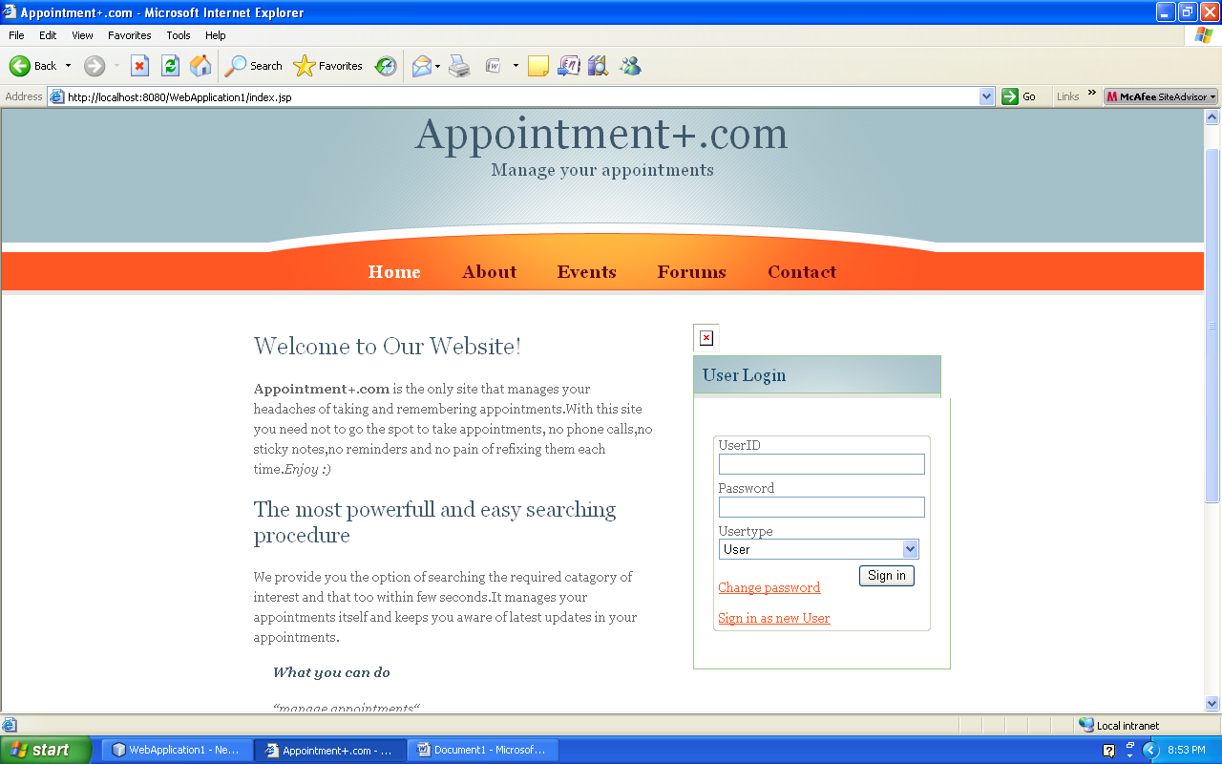
USER TASKS 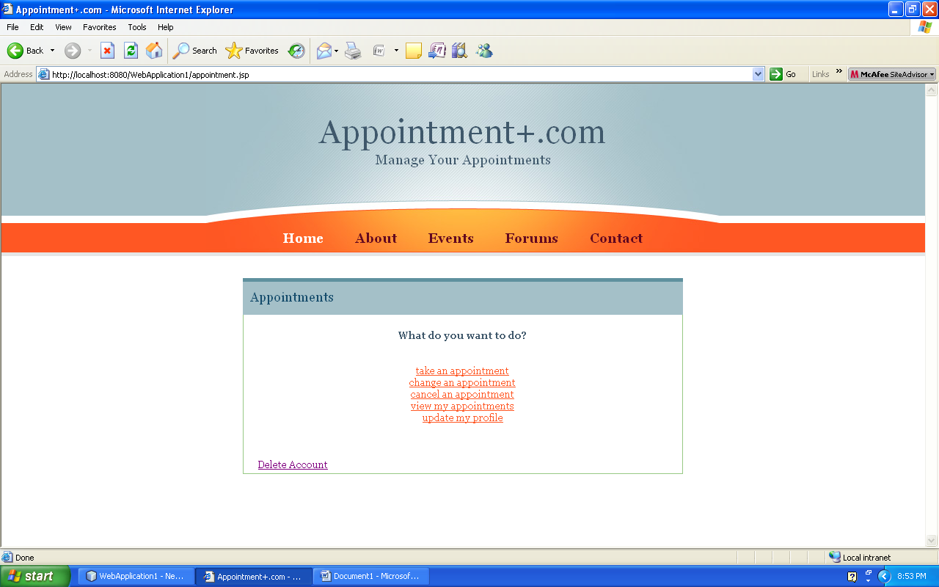
ADMINISTRATOR PAGE
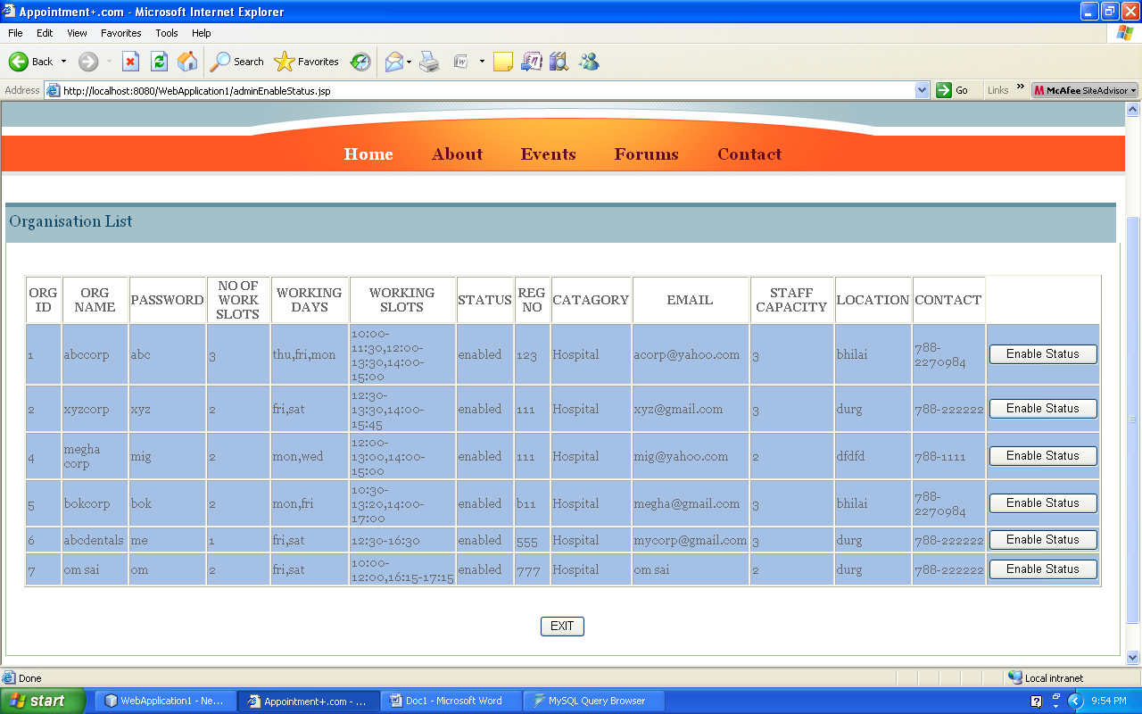REGISTRATION PAGES
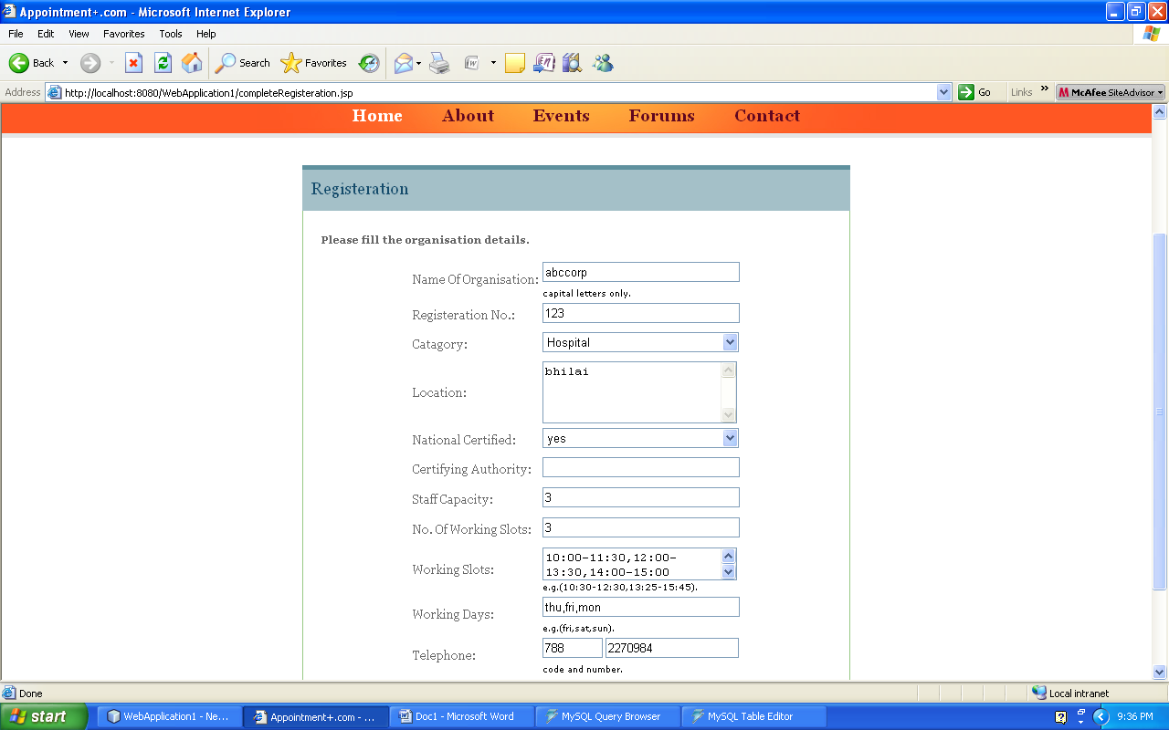
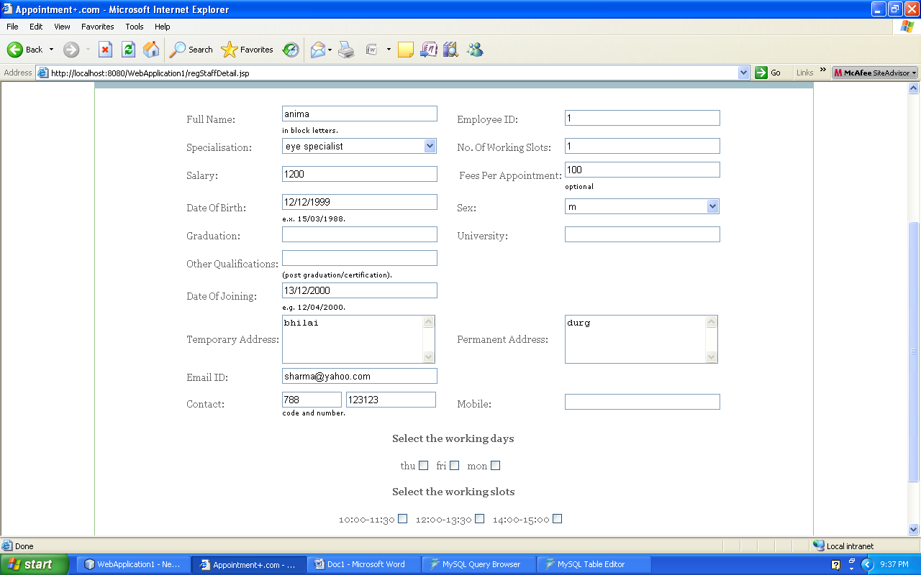SEARCH SPECIALIST
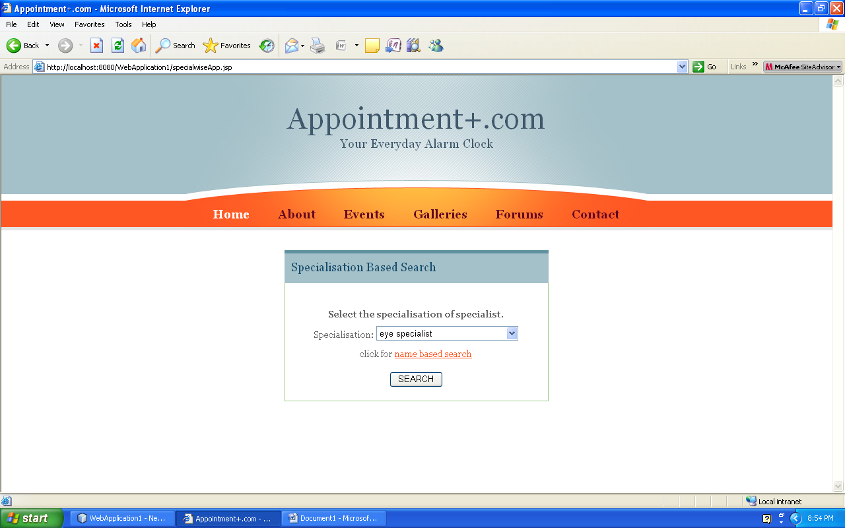

SELECT SPECIALIST
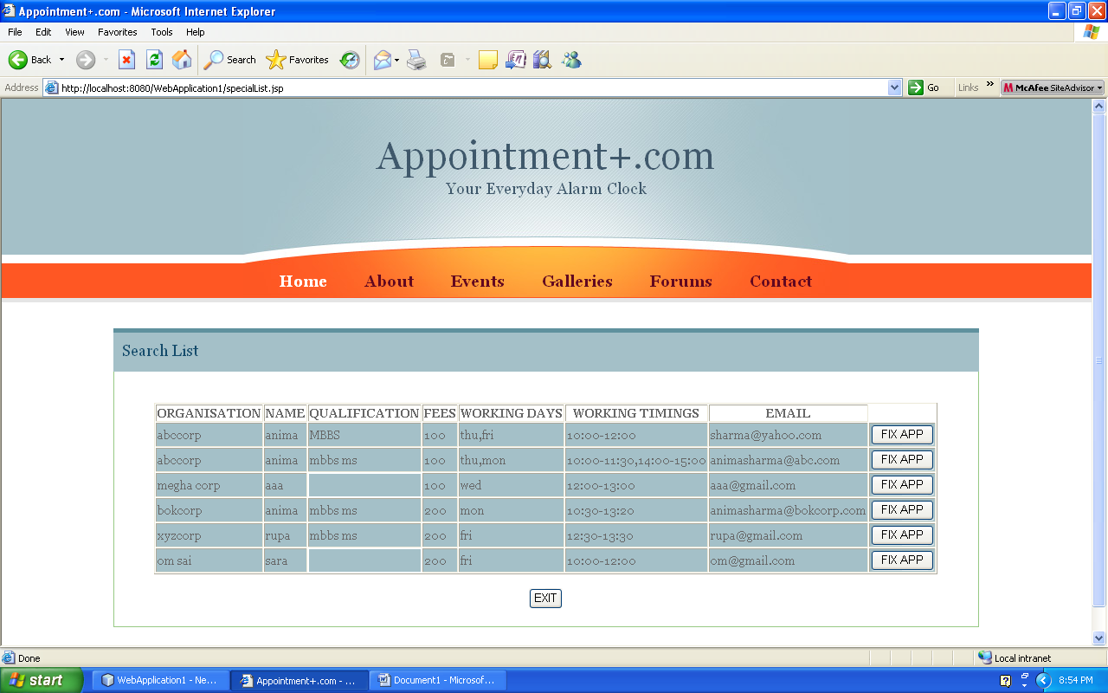SELECT TIME AND SLOT OF APPOINTMENT
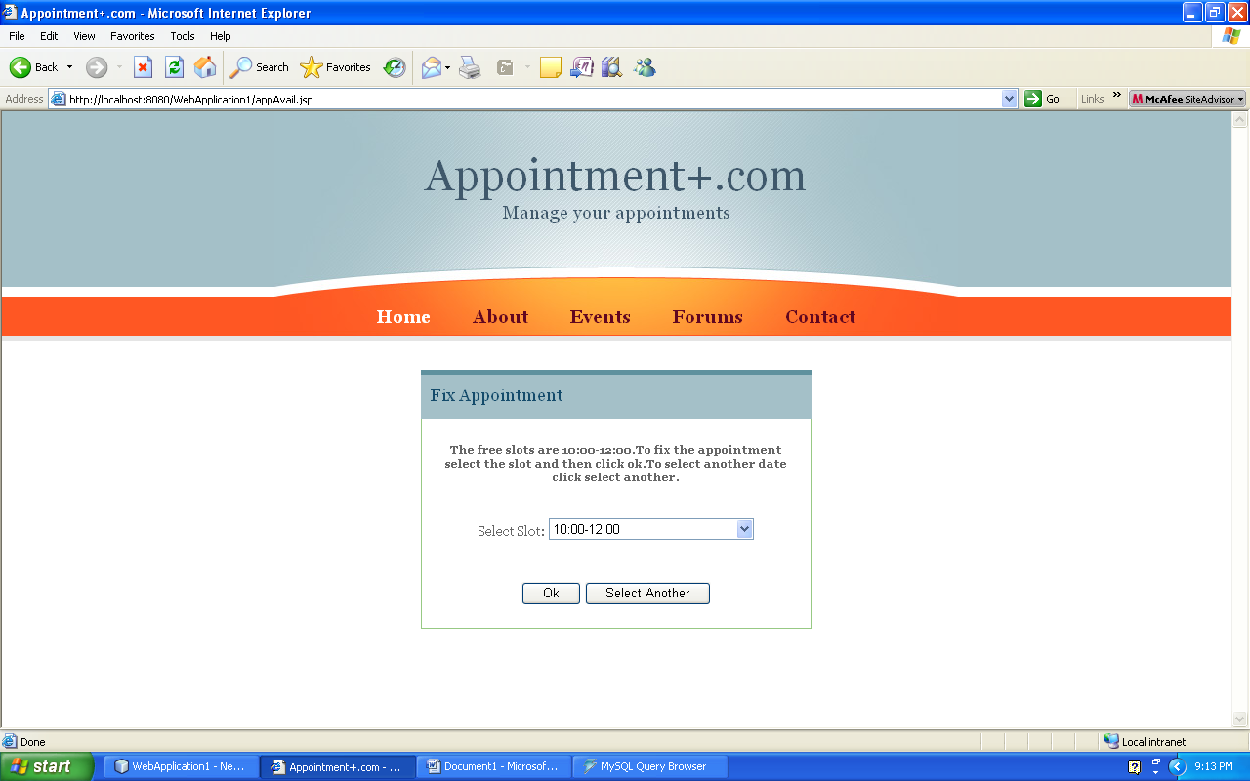
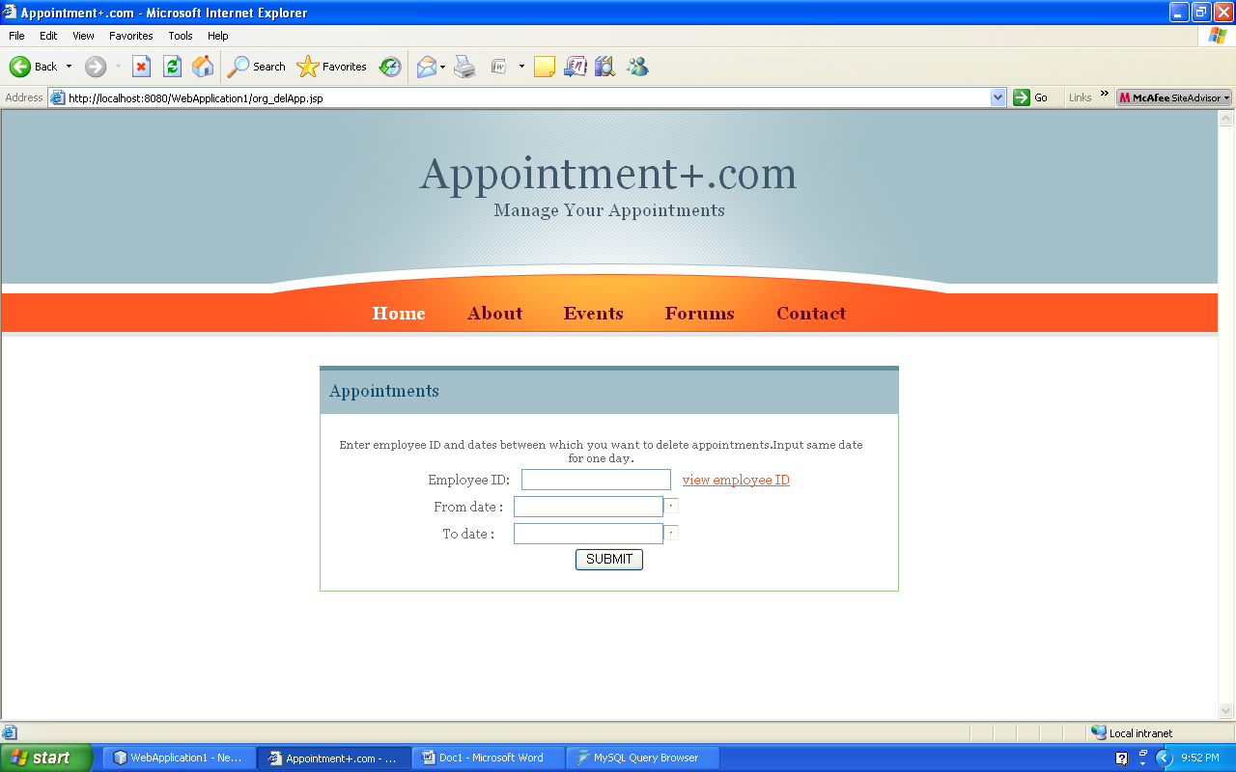
DELETING APPOINTMENT
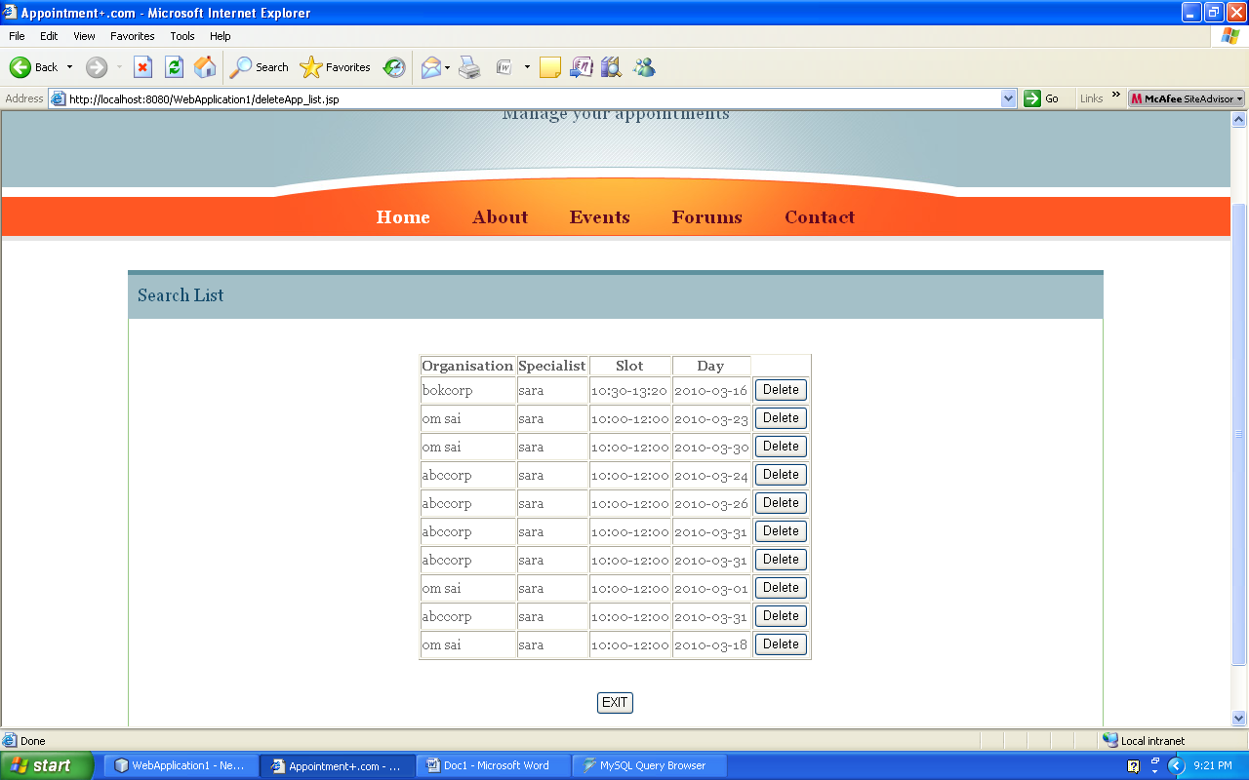

CONCLUSION & SCOPE OF FUTUREWORK

CONCLUSION& SCOPE OF FUTUREWORK

CONCLUSION

Here upon the project has been developed with the intention to automate the APPOINTMENT MANAGEMENT SYSTEM. The concept of developing "APPOINTMENT+.COM" is to reduce the time consumption for visiting the organization and to provide the users the information about various organizations and specialists.
With the conclusion of our project, we hope that our work will be proved helpful and will help organizations and clients to conduct appointment related operations successfully, effectively with an ease.

SCOPE OF FUTURE WORK

- An online advance payment before fixing an appointment is yet to be implemented.
- Sharing the same place by more than one specialist is complex and yet to be implemented.

BIBLIOGRAPHIE

BIBLOGRAPHIES

BOOKS

Professional JSP….J2EE 1.3 Edition

Writer:-Subramanyam Allmaraju

Pure Java Server Pages

Writer:-James Goodwill

Complete Refrence J2EE.

WEBSITES

www.google.com

